Ko wai mātou? Who are we?

ORAL HISTORY CONFERENCE

**Stout Research Centre for New Zealand Studies &**

**National Oral History Association of New Zealand (NOHANZ)  
Te Kete Kōrero-a-Waha o Te Motu**

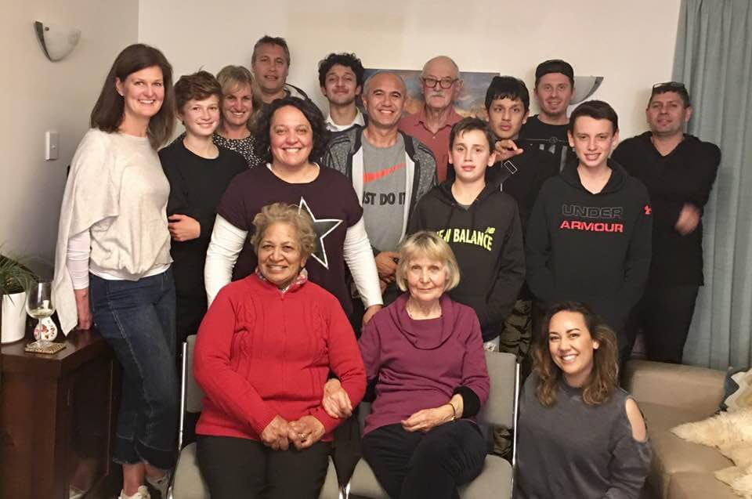

*Te Rito Whānau (Ngāti Kahungunu/Rongomaiwahine)*

*Grateful thanks for permission to use this photograph.*

20-22 November 2020

Te Herenga Waka Victoria University of Wellington

<https://www.victoria.ac.nz/stout-centre/about/events>  
<http://www.oralhistory.org.nz/>

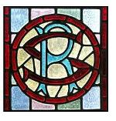 

**STOUT RESEARCH CENTRE  
 *for New Zealand Studies***

**Welcome**

Nau mai, haere mai ki Whanganui-a-Tara. Welcome to Wellington.

Te Kete Kōrero-a-Waha o Te Motu/The National Oral History Association of New Zealand (NOHANZ) and The Stout Research Centre for New Zealand Studies, Te Herenga Waka Victoria University of Wellington warmly welcome you to the 2020 oral history conference.

Our theme for the conference is ‘Ko wai mātou? Who are we?’, and over the next two days oral historians from around New Zealand will discuss a range of perspectives and approaches arising out of their communities and research projects. We were delighted to receive so many paper proposals, given the uncertain national context of the global pandemic, and we look forward to seeing you all.

The programme is a mixture of panels and papers; the panels have been allocated one hour and the papers half an hour. Please ensure that your paper is no longer than 20 minutes, with 10 minutes for questions and discussion. We have a full programme, and it is very important that speakers and sessions do not run over their allocated time.

If you have any concerns or questions, please approach one of the members of the planning committee. These are: Anna Green, Debbie Levy and Richard Hill (SRC) and Lynette Shum, Ann Packer and Debbie Dunsford (NOHANZ).

Further general information may be found towards the back of this programme on p. 23.

**We are grateful to our supporters and sponsors:**

Te Herenga Waka - Victoria University of Wellington

Ministry for Culture and Heritage

Jack Ilott Fund

National Library of New Zealand Te Puna Mātauranga o Aotearoa

We must add the caveat that should community transmission of the Covid_19 virus re-emerge we may have to cancel the conference at relatively short notice. We strongly recommend that you book refundable or transferable flights.

**Conference Schedule**

|  |  |  |
| --- | --- | --- |
| **Friday 20 November 2020** | | |
| 9.00am - 4.00pm | Oral History Workshop Programmes:   * Telling audio stories using oral history. * Oral History with Pictures. * Plan for the best; plan for the worst: Managing OH Collections. * History Walk with WalkWellington:   Old Government House, parliamentary precinct, National Library, Thistle Inn, Old St Paul’s. | National Library of New Zealand Te Puna Mātauranga o Aotearoa.  Meet 1 p.m. at the Supreme Court, 85 Lambton Quay. |
| 5.00pm | Mihi Whakatau  Conference Opening and Welcome | Auditorium Lower Ground Floor National Library of New Zealand Aitken Street Entrance, Wellington  Introduced by: Nepia Mahuika |
| 5.30pm | Opening Keynote Lecture  Tā Kim Workman and Julia Amua Whaipooti |
| 6.30pm - 7.15pm | Drinks Function | Auditorium Foyer,  National Library of New Zealand |

|  |  |  |
| --- | --- | --- |
| **Saturday 21 November 2020** | | |
| 8.15am | Registration Desk Open Alan MacDiarmid AM foyer  Victoria University of Wellington Te Herenga Waka, Kelburn Campus | |
| 8.45am | Kirk 301 (KK 301) lecture theatre Housekeeping and conference information. (Stout/Nohanz). | |
| 9.00am | Keynote Speaker: Li Na  Kirk Lecture Theatre 301 (KK301) Chair: Lynette Shum  Via Zoom | |
| 10.00am | Kirk Lecture Theatre 301 (KK301)  **One-minute lightning presentations**  Chair: Debbie Dunsford  (tell us in 60 seconds about the focus of your oral history research project). | |
| 10.30am | Morning Tea at AM Foyer | |
|  | AM101 - STREAM 1 | AM102 - STREAM 2 |
| Chair | Megan Hutching | Helen Frizzell |
| 11.00am | Robert McClean  “But was it a ‘Very Nice Honeymoon’? Memory, Forgetting and Heritage - the case of the Vella family story” | PANEL 1  Caren Wilton, Jacqui Keelan, Pia Kahn, Debbie Dunsford, Sue Berman, Will Hansen, Anaru Dalziel and Emma Jean Kelly, Zemara Waru-Keelan  ‘Kei roto I te muri, Inside the Bubble’ Covid-19 pandemic lockdown oral history project. |
| 11.30am | Bobby Hung “Capturing the story of NZ graffiti through participatory methods of oral history” |
| 12.00 noon | Chris Hay  “Place-based narratives and the NZ Wars” | Ken Ross  “General Sir Bernard Freyberg – a New Zealander?” |
| 12.30pm | Lunch AM Foyer | |
|  | AM101 - STREAM 1 | AM102 - STREAM 2 |
| Chair | Cheryl Ware | Anna Green |
| 1.30pm | Julie Benjamin  “Everyone Knew Him: Exploring Buller Identity in Dunedin” | Elizabeth Ward  “Kiwi-made Vets – interviews with foundation staff and early students of Massey University’s School of Veterinary Science” |
| 2.00pm | Sonia Pivac  “Navigating the Narratives: Sign Language Deaf National Archive” | Natalie Looyer  “Building a life story through collective memory” |
| 2.30pm |  | Sabina Rehman  “’Footprints in the sand of time’: Life histories of people who try to make a difference in the lives of others and themselves”  WITHDRAWN |
| 3.00pm | Afternoon Tea | |
| Chair | Keri Mills | Sue Berman |
| 3.30pm | Rewi Nankivell  “Waiho mā te Pūrākau hei Korero: How does the use of pūrākau support te reo Māori revitalisation for Ngāti Rora hapū, Te Kūiti?” | Michael Dudding  “Coherence in oral history narratives: locating the ‘self’ within canonical identities” |
| 4.00pm | Nathan Williams  ‘Growing Up Ngāti Kahu’ | PANEL 2  “What is Interviewing?”  Anna Green, Helen Frizzell, Pip Oldham, Megan Hutching |
| 4.30pm | Zechariah Reuelu  The Tokelau New Zealand Journey  *“E laga kita ko te fanau ko te lumanaki ia o fenua” - Whatever we do is for the children, the future of the land – Tokelau Proverb* |
| 5.00pm | NOHANZ Annual General Meeting  Room AM102 | |
| For list of recommended cafes and restaurants for dinner – see end of programme. | | |

|  |  |  |
| --- | --- | --- |
| **Sunday 22 November 2020** | | |
|  | AM101 - STREAM 1 | AM102 - STREAM 2 |
| Chair | Ann Packer | TBC |
| 9.00am | Judith Aitken  “Valuing Women” | Jock Walker and Mohan Lal  “Tirohanga Whānui” |
| 9.30am | Cybèle Locke  “Rona Bailey on being Communist, being Pākehā: from the anti-apartheid movement to Project Waitangi” | Jani Wilson  “Words, Melodies and Hooks: Waiata and Oral History” |
| 10.00am | Barbara Einhorn“Speaking and Not Speaking: The Transformation of New Zealand’s Approach to ‘Others’” | Taina McGregor  “Ole Jose” |
| 10.30am | Morning Tea | |
| 11.00am | Keynote speaker: Melissa Williams  Kirk Lecture Theatre KK 301  Chair: TBC | |
| 12.00pm | Book Launch, Nepia Mahuika, *Rethinking Oral History and Tradition: An Indigenous Perspective* (Oxford University Press)  Introduced by Linda Tuhiwai Smith  Room AM102 | |
| 12.30 – 1.30pm | Lunch | |
|  | AM101 - STREAM 1 | AM102 - STREAM 2 |
| Chair | Emma Kelly | Ruth Low |
| 1.30pm | Liana MacDonald  “Learning to listen and live with multiple indigenous and settler perspectives of historical colonial violence: the Wairau Affray” | Sue Berman“Ngā Pātaka Kōrero o Tāmaki Makaurau – “Auckland Stories Archive” |
| 2.00pm | Marama Muru-Lanning and Keri Mills  “Listening to the voices of our harbours” | Rosemary Baird  “Aotearoa Unearthed: A podcast about archaeology” |
| 2.30pm | Tea and coffee break | |
|  | AM102 |  |
| Chair | TBC |  |
| 3.00pm | Panel 3 Emma Jean Kelly, Chris Szekely, Nepia Mahuika  “Ka mua, ka muri: where to from here?” | |
| 4.00pm | Close of Conference - AM 101 - Poroporoaki  Anna Green | |

**Opening Lecture**

**Friday 20 November 2020**

**Auditorium**

National Library of New Zealand Te Puna Mātauranga o Aotearoa

Lower Ground Floor, Aitken Street Entrance, Wellington

**5.00pm Welcome – Mihi Whakatau**

5.30pm – 6.30pm Keynote Address

6.30pm - 7.15pm Drinks Function

**Tā Kim Workman**

Ngāti Kahungunu ki Wairarapa, Rangitāne o Wairarapa

and

**Julie Whaipooti**

Ngāti Porou

**In Conversation**

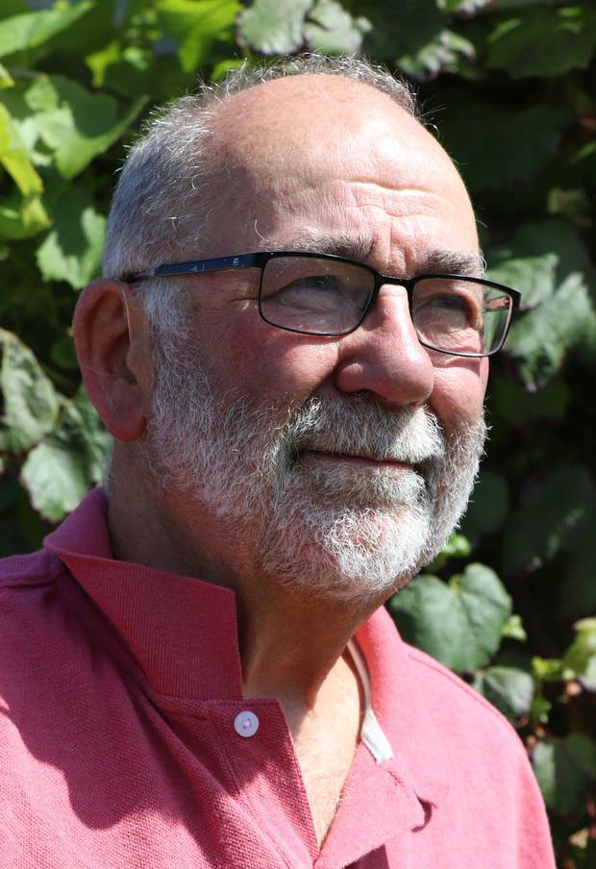

**Tā Robert Kinsela (Kim) Workman   
KNZM QSO**

**Kim Workman** (of Ngāti Kahungunu ki Wairarapa and Rangitāne) is a retired public servant, whose career spans roles in the Police, the Office of the Ombudsman, State Services Commission, Department of Māori Affairs, and Ministry of Health. He was Head of the Prison Service from 1989 – 1993. He is a graduate of Massey University, and has completed post-graduate study at the University of Southern California, and Stanford University. In 2000, Kim was appointed National Director, Prison Fellowship New Zealand (PFNZ), and retired from that position in 2008. In 2005, Kim was the joint recipient (with Jackie Katounas) of the International Prize for Restorative Justice.

He was made a Companion of the Queens Service Order (QSO) in 2007. He served as a Families Commissioner from 2008 – 2011. In 2006 Kim joined with the Salvation Army, to launch the “Rethinking Crime and Punishment” (RCP) Project. In 2011 he formed Justspeak, a movement that involves youth in criminal justice advocacy and reform. Over the last five years, Kim has increasingly contributed to the academic literature, in the areas of criminal justice policy, Treaty and Māori development issues, racism and inequality, culture and identity. He is currently an adjunct research associate at the Institute of Criminology, Victoria University. In 2015 he was awarded the R.D. Stout Fellowship at the Stout Centre for New Zealand Studies, and is currently completing a publication on “The Criminal Justice System, the State, and Māori from 1985 to the present”. In 2016, Kim was awarded the degree of Doctor of Literature (*DLitt Well*) by the Council of Victoria University, and in 2017, the same degree by the Council of Massey University. In February 2018, Kim was awarded Senior New Zealander of the Year, under the New Zealander of the Year Awards Scheme.

In 2019, Kim was appointed as a Knight Companion to the New Zealand Order of Merit (KNZM). In the same year, he completed an eight-month intensive te reo course at Te Wānanga o Raukawa. His memoir, ‘Kim Workman – Journey Towards Justice’ was published in November 2018.

Earlier this year, Kim was appointed to the Human Rights Review Tribunal and the NZ Parole Board.  He is also on the he Police External Advisory Group on Pae Oranga (Iwi Community Panels) and was recently appointed by King Tuheitia to represent the Kingitanga as Co-chair on the Kawenata Governance Board, a Memoranda of Understanding between the Kingitanga and Te Ara Poutama (the Department of Corrections).

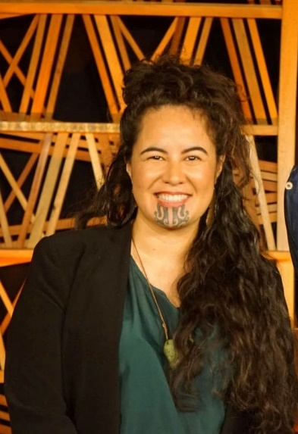

**Julia Amua Whaipooti**

**(Ngāti Porou)**

Julia is an aunty and soon to be mother whose core advocacy revolves around creating a place to live that nurtures the full potential of future generations.

Julia is a strong advocate for systemic change particularly of New Zealand’s criminal justice and associated care and protection systems. In 2018 she was appointed to Te Uepū Hāpai i te Ora – the Safe and Effective Justice Advisory group. She currently works as a Senior Advisor at the Office of the Children’s Commissioner; is a member of the Kaiwhakatara Advisory Group to the Human Rights Commission; a Board Member to the New Zealand Drug Foundation; former Chair of Justspeak and the Robson Hanan Trust and was been involved in the Community Law movement as a volunteer, advocate, lawyer and National Māori Co-ordinator.

Julia believes people with lived experience, young people, whanau and community provide the expertise needed for true transformative change and must be listened to.

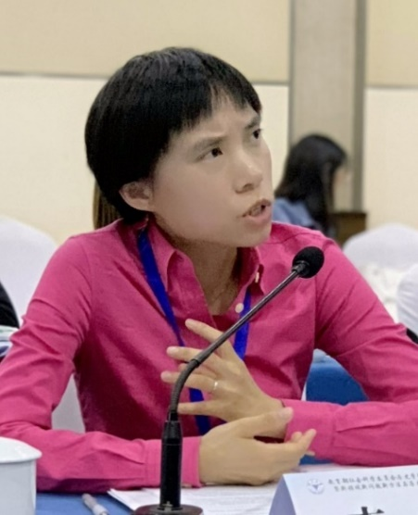

**Professor Na Li**

**Oral History, Public Memory, and Political Identity:**

**A Transnational Dialogue**

Oral history has attracted steadily increasing scholarly and public attention in China during the past two decades. The talk surveys the landscape of oral history in China and addresses two core questions: first, why has oral history become popular with such scope and intensity? Second, how does oral history influence the historical consciousness of a cross-section of ordinary Chinese? With this, I will call for a more critical analysis of the diverse and dynamic oral histories in a broader transnational context.

**Na Li** is a Research Fellow/Professor at Department of History, Zhejiang University (2017-). She worked as Research Fellow/Professor at the Institute for Advanced Humanities and Social Sciences, Chongqing University (2013-2017). She is Editor for Public History: A National Journal of Public History (《公众史学》), and International Consulting Editor for The Public Historian. She served on the Board of Directors for the National Council on Public History (2017-2020). Her research focuses on public history and urban preservation. Her first book, Kensington Market: Collective Memory, Public History, and Toronto’s Urban Landscape (University of Toronto Press, 2015) investigates ethnic minority entrepreneurs in one of the most diverse neighborhoods, Kensington Market in Toronto, incorporates collective memory in urban landscape interpretation, and suggests a culturally sensitive narrative approach (CSNA) to urban preservation. The Chinese edition is published in 2017 (Shanghai Joint Publishing Company). Her second book, Public History: A Critical Introduction, surveys key issues in public history (Peking University Press, 2019). Her articles appeared in The Oxford Handbook of Urban Planning, History Workshop Journal, Journal of Family History, The Public Historian, Oral History Review, Public History Review, Public History Weekly and a number of premier Chinese journals. She is now working on her new book, *Seeing History: Public History in China*.

Na Li contributes to a better understanding of public history at an international scale. She is International Affiliate of the Centre for Oral History and Digital Storytelling at Concordia University, Canada, and an Associate of Australian Centre for Public History at University of Technology Sydney, Australia. She is at a forefront to research and establish public history in China. She has organized the National Public History Seminar (Chongqing 2013); National Public History Conference (Suzhou 2013; Hangzhou 2018); Public History Faculty Training Program in China (Shanghai 2014, Chongqing 2015, Hangzhou 2019).

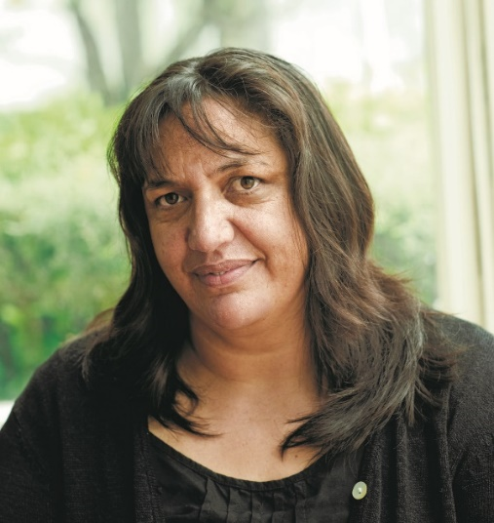

*Photo credit: Neil Pardington*

**Dr Melissa Matutina Williams**

**‘Oral history is at once all and nothing about who “we” are’.**

Reflecting on the oral narratives that inform my book, *Panguru and the City: Kāinga Tahi, Kāinga Rua*, I explore the idea that oral history is at once all and nothing about who ‘we’ are. When I began my research, one of my aims was to challenge the ways in which Aotearoa New Zealand’s national histories marginalise and stereotype Māori people into hapless victims of urbanisation. I believed (and still do) that such histories misrepresent and discredit the ambitions and achievements of a generation of Māori, including my own elders. My talk will focus on the processes of collecting and writing the individual voices of my whanaunga into the centre of an iwi urban migration narrative, and how I navigated layered expressions of national, Māori, iwi, whānau and individual identity. In turn, I suggest that the oral histories we collect may provide answers about who ‘we’ are, but that those answers also reflect who you are,  what brought you to your place of oral history enquiry and what you intend to do with the kōrero entrusted to you.

Melissa Matutina Williams is of Te Rarawa and Ngāti Maru descent. Following the completion of her PhD in History in 2010, she lectured for three years in Māori and New Zealand history at The University of Auckland where she now holds an honorary academic position. Melissa's publications include her award-winning book, *Panguru and the City: Kāinga Tahi, Kāinga Rua*, which is based on the oral histories of her whanaunga who migrated from North Hokianga to Auckland, 1930-1970. Melissa continues to research and write in the fields of Māori and New Zealand history and is currently part of a Marsden project team researching “Whanau Ora with, against and beyond the state”.

**Abstracts**

**Aitken, Judith  
Valuing women**

Within the broad theme “Ko wai matou: Who are we?” this paper will tell the stories of women whose lives and work are often almost invisible in the community and workforce. The focus will be on how they faced and overcome disadvantages of birth and circumstance to make extraordinary, albeit typically under-valued, contributions to New Zealand/Aotearoa. The paper will be based on two oral histories: “Women in a Disabling World”, lodged in the National Library in 2019. This history provides an illuminating way to describe how the social, economic and other contexts of daily life impact on and exacerbate the challenges facing women with disabilities. The second, a much larger project involved interviewing some 60 women, is being produced by a small group of volunteers. It is titled “Keystrokes per minute – an oral history of women working in New Zealand Public Service typing pools 1945 to the present” (KSPM). The recordings have been transcribed and the project group plans to publish a book based on the women’s stories. Both projects were awarded generous grants by the Ministry of Culture and Heritage, with benevolent funding from the State Services Commission.

Bio  
Dr Judith Aitken is a school teacher by trade and a former public servant, local government councillor and DHB board member. In recent years she has trained in oral histories and undertaken three: “Keystrokes per minute” as part of a small energetic team of women and the third a personal history completed immediately before the death of the prominent Wellington woman.

**Baird, Rosemary  
Aotearoa Unearthed: A podcast about archaeology**

In this paper I’ll reflect on the experience of making a podcast, Aotearoa Unearthed: Archaeology for Everyone, as part of my work at Heritage New Zealand Pouhere Taonga. This podcast was made in partnership with the New Zealand Archaeological Association. This paper will reflect on three main questions:

* What can archaeology say to us as New Zealanders about our individual and collective identity and history?
* How do you practically go about making a podcast as a raw beginner (recording in Covid times via zoom, using the Hindenburg audio editing software, podcast hosting platforms, creating a hero image etc).
* How much do I allow my own identity to be part of the podcast in my role as ‘host’?

The often frustrating, always thrilling experience of making this podcast gave me a lot of time to think about the messages I was trying to convey to listeners about New Zealand histories and how we connect to our ancestors. Plus, it confirmed my belief that archaeology is awesome.

Bio

Rosemary Baird completed her PhD in oral history at the University of Canterbury in 2012 and has done extensive oral history interviewing around the Canterbury earthquakes and the Manapouri Hydro Scheme. She currently works as an Outreach Advisor for Heritage New Zealand Pouhere Taonga.

**Benjamin, Julie  
Everyone Knew Him: Exploring Buller Identity in Dunedin**

In this paper I explore stories of a ‘character’ or ‘identity’ within the recollections of a selection of residents and former residents of the Buller District. I will focus on a recently completed series of oral histories, in which interviewees recalled how they travelled by excursion train to Dunedin in 1949 to support the Buller rugby team in a match against Otago. The word ‘community’ can mean residents of a district. It can also refer to a sense of common identity and character which helps a person feel that they belong with particular others. ‘Identity’ can similarly mean the qualities of a person or group that makes them different from others. I will discuss how the oral narratives of Buller rugby supporters, now aged 80 and over, often included memories of a Buller character, their recollections of this ‘different’ person pointing to a community identity.

Bio  
Julie Benjamin is an independent Auckland historian. She has a particular interest in West Coast (South Island) history, storytelling, slide photography, and women’s histories.

**Berman, Sue**

Ngā Pātaka Kōrero o Tāmaki Makaurau - Auckland Libraries is the repository for oral histories and sound recordings that make up a diverse and ranging “Auckland Stories” archive. This paper will illustrate the value of recordings on the theme of place and will draw across decades of projects commissioned or gifted to the collection. I will examine how the collections of recording of local voices illustrate the richness of the social and cultural dimensions that contribute to a Tamaki/Auckland identity of place. The talk will include extracts that intersect other identities too, illustrating the multiple identities that people weave through an oral history narrative.

Bio

Sue Berman has been involved in oral history and community development work for close to 30 years. Her range of experience includes family, organisational and place based oral history projects, three with NZ Oral History Awards funding. She currently works for Ngā Pātaka Kōrero o Tāmaki Makaurau - Auckland Libraries as the Principal Oral History Advisor in Heritage Collections – Engagement.

**Dudding, Michael  
Coherence in oral history narratives: locating the ‘self’ within canonical identities.**

**Psychologist Jerome Bruner stated in 1969 that autobiographical writings represent a narrator’s attempt to reconcile their many past selves into the singular person who is currently narrating their life. The events experienced by past selves, along with meanings ascribed to those events, are thus shaped by the contemporary desires of the present narrator. This shaping has dual aims: the presentation of a consistent narrative to a knowing external audience (one that accords to accepted social and historical constructions); and secondly, the creation of a coherent ‘self’ as a more or less active agent within those broadly accepted narratives. This paper proposes that oral histories, where the narrator is given meaningful authority over the direction of their narration, shares with autobiography these same fundamental parameters of identity construction (among other influences). In light of this proposition, it is argued that meaning might be found by critically examining the individually constructed identity both within and against the socially constructed narratives that contain them. It is here, in the uncomfortable liminality between personal testimony and canonical myth, that interpretive space is richest and the connectedness between the self and socially constructed identities can begin to shed light the question of “Who are we?”.**

**Bio  
Michael Dudding is the First Year Coordinator at the School of Architecture, where his oral history-based research records the experiences of New Zealand architects, in order to supplement our existing understanding of New Zealand post war architectural history.**

# **Einhorn, Barbara**

# **Speaking and Not Speaking: The Transformation of New Zealand’s Approach to ‘Others’**

Speaking and not speaking: It’s one of the most fundamental questions in Oral History, and in self-identification, particularly for those finding their way into a different culture. You know you are ‘other’, adapting to a new culture. You also know you are entering a culture itself changing its attitudes to newcomers. I want to address that transition in New Zealand through my current semi-autobiographical project on transnational identity. This paper uses oral testimony from my parents, together with archival sources as a case study. The conference will help me map the larger question of who we are collectively now, and how we’ve changed from who we were when Ester and Helmut Einhorn arrived in Wellington on a bright winter’s day in July 1939, fleeing Hitler’s Germany to sanctuary in New Zealand.

To what extent does the degree of suspicion and prejudice then contrast with the outpouring of solidarity in reaction to the Christchurch massacre? How did the two groups of newcomers, Jews and Muslims, feel enabled to speak by their host society? Were their feelings of acceptance affected by their own integration strategies as well as by evolving community attitudes? My observations will be coloured by my own arrivals and returns; to Britain, Germany, New Zealand.

Bio  
I was born in Wellington as the daughter of German-Jewish refugees from Hitler and have spent my adult life crossing disciplinary boundaries and geographical and political borders. I am Professor Emerita of Gender Studies at the University of Sussex in the UK and Visiting Researcher at the Stout Centre. My research has focused on gender, citizenship and nationalism; and oral histories of migration and return.

**Green, Anna, Helen Frizzell, Pip Oldham, Megan Hutching - Panel**

**“What is Interviewing?”**

How does oral history interview practice constrain or enable the expression of identity? In this interactive panel session we would like to engage with members of the audience on this question. Each of us will speak briefly to a particular issue we are thinking about in the context of interview practice, then open it up to the audience for their perspectives and comments. Topics include: the format of the interview (narrative or question-led); listening and finding questions; the relationship between the interviewer and interviewee; and who decides what is valuable or important in the interview? We anticipate that the discussion will range widely and welcome contributions from the audience. The four members of the panel have a wealth of interviewing experience in a wide range of contexts, including commissioned interviews, independent projects, and academic research.

Bio

Anna Green is an associate professor and oral historian in the Stout Research Centre at Victoria University of Wellington, Helen Frizzell is a freelance oral historian and is based in Dunedin, Megan Hutching is a freelance oral historian based in Auckland, and Pip Oldham is a freelance oral historian in Wellington.

**Hay, Chris**

**Place-based narratives and the New Zealand Wars**

Can contested historical sites provide a fresh way of understanding who we are as New Zealanders and help us reframe our narratives of who we are as a nation? This paper and audio-visual presentation explores examples of how seemingly everyday landscapes can be transformed through personal stories and accounts to help re-conceptualise New Zealand history. Te Ara Wai Journeys is a project that allows visitors to explore a series of locations in the Waipa District through the voices of the local community. Over 160 stories are shared on the sites themselves through a mobile website as video, audio and graphic novel stories. The story of each site is told from multiple perspectives, each adding to the collective memory of what the New Zealand Wars were, how they were fought and their implications for today. This paper explores how this works in practice and also future challenges to overcome including the selection of interviewees and the implications of local perspectives versus meta-narratives.

Bio

Chris Hay is the Director of Locales, a place-based storytelling agency in Wellington. He specialises in creating community storytelling projects for historic sites and cultural landscapes.

**Hung, Bobby**

Capturing the story of New Zealand graffiti through participatory methods of oral history. In a video project titled the ‘Real Time Web Series’ (RTWS), Bobby Hung explores the various perspectives of past and present graffiti writers in an in-depth process video meets podcast. Available as an online educational resource, the video captures the real time working process of a piece from start to finish, accompanied by a semi structured interview of questions created by the online audience, and featuring over 200 images in each episode. The series provides visual and verbal insight into the social and cultural contexts underpinning the development of graffiti in New Zealand, the cultural identity of its graffiti writers, understanding of the practical applications of production, and an exploration of the implications in adopting ideologies of American graffiti in New Zealand. The RTWS aims to close the gap between intergenerational knowledge, provide a platform to record the rich stories and experiences of an ephemeral art form, and understand how the mode of graffiti can mediate the discovery of a collective cultural identity.

Bio

Dr Wing Tai (Bobby) Hung is an artist, researcher, and teacher currently lecturing in the Creative Industries at Unitec Institute of Technology. His research interests centre around visual arts education and the documentation of graffiti and street art in New Zealand.

**Kelly, Emma Jean, Nepia Mahuika, Chris Szekely**

**Ka mua, ka muri: where to from here?**

2020 marks the 30th anniversary of the Australian government sesquicentennial gift to New Zealand of $1m to support oral history, which created the oral history award scheme, now known as Ngā Kōrero Tuku Iho. 2020 also marks the 100th anniversary of the opening of the Alexander Turnbull Library.  Anniversaries provide an opportunity to look back and learn, in order to move forward. Panellists will discuss opportunities to take oral history forward in ways that are practical, inclusive and build on New Zealand’s tradition of standards-based practice.

Panel:

Dr Emma Jean Kelly is Pou Hītori (Ataata-Rongo) Historian Audio-Visual for Manatū Taonga, the Ministry for Culture and Heritage. She worked previously at the Waitangi Tribunal as a researcher, and prior to that, collected and examined oral histories for her study of Jonathan Dennis, founder of Ngā Taonga Sound & Vision, the NZ Film & Sound Archive. Emma is English, Irish, Scots and Welsh and grew up in Tāmaki Makaurau. She is committed to working in partnership using Te Tiriti o Waitangi as a foundation, and loves listening to all the kōrero of Aotearoa New Zealand.

Dr Nepia Mahuika is chair of Te Pouhere Kōrero Māori Historians Collective Aotearoa and president of the National Oral History Association of New Zealand. In 2019 he was the recipient of the Judith Binney Fellowship to support completion of a research project on the history of makutu in Aotearoa New Zealand. He is currently Senior Lecturer in History at the University of Waikato and the author of the book ‘Rethinking oral history and tradition: an indigenous perspective,’ published by Oxford University Press.

Chris Szekely is Chief Librarian of the Alexander Turnbull Library, a position he has held since 2007. He was previously City Librarian at Manukau in the 7 years leading up to the establishment of the Auckland ‘super city.’ Born and raised in South Auckland he continues to be an advocate for inclusive library services. He is a Fellow of the Library & Information Association of NZ Aotearoa, and a founding and life member of Te Rōpū Whakahau, the national association for Maori in the information profession.

**Kelly, Emma**

**Panel Discussion Ministry for Culture & Heritage and Auckland Libraries**

**‘**‘**Kei roto i te muri, Inside the Bubble’ Covid-19 pandemic lockdown oral history project.**

**Ko wai mātou? Who are we?**

At the Ministry for Culture and Heritage, we are charged to promote a confident and connected culture: he ngākau titikaha, he hononga tangata. We are a treaty partner and support iwi/Māori cultural priorities, and more generally provide advice and support on a range of arts, cultural and heritage policies. So what happens when a pandemic hits and the country is locked down? How can we help keep New Zealanders connected? Partnering with Sue Berman Principal Oral History Advisor Auckland Libraries, Oral Historian Dr Emma Jean Kelly and AV Guru Anaru Dalziel got on Zoom and hatched a plan to use free online software to encourage 10 oral historians from various communities around the country to collect short oral histories with our support. To date 35 oral histories have been received with people including Ngati Porou, LGBTQ+, rural Pākehā, health workers, writers, musicians, young Mums, Pacific Island New Zealanders, Northland community workers and Chinese New Zealanders. A number of the oral historians involved in the project will present together on the challenges, benefits and learnings of this experimental process which became ‘Kei roto i te miru, Inside the Bubble: Covid-19 pandemic lockdown oral histories’.

Speakers:

Debbie Dunsford is an independent historian with oral history at the heart of her research. She loves the way people's stories merge their unique and common experiences to give rich insights into day-to-day life in the past.

Emma Jean Kelly (she/her) is the Audio-Visual Historian at Manatū Taonga, Ministry for Culture and Heritage. She loves creating platforms for communities to share their stories. Her favourite work is collaborative, which is chaotic, but also fun and very rewarding.

Anaru Dalziel is an audio visual guru who supports the production of podcasts, documentaries, and other publications. He works part-time at Manatū Taonga and also runs his own business, Valley Audio. Anaru enjoys finding innovative ways to share stories.

Jacqui Keelan is Ngati Porou and lives in the Waikato. She descends from the people of Maui. She is an artist, historian and Oral Historian. She has a strong interest in many forms of ngā kōrero tuku iho including waiata and shared korero following her whānau and hapū traditions.

Pia Maria Kahn received funding from Manatū Taonga in 2019 for her project, *New Zealand’s ‘happiest migrants’*: An introductory oral history of Filipino migrants in New Zealand. She is a writer and oral historian.

Caren Wilton is an oral historian, writer and editor, and was the recipient of three New Zealand Oral History Awards for her series of interviews with sex workers (on which My Body, My Business is based). An editor at Te Ara – the Encyclopedia of New Zealand for almost nine years, she is also a freelance book editor.

Clara Souza da Frota is a student at the Museum and Heritage Masters course of Victoria University. She is currently an intern at Manatū Taonga, Ministry for Culture and Heritage, and has a passion for oral history and immigration stories.

Zemara Waru-Keelan is a PhD student at Waikato University, a mental health advocate and musician.

**Locke, Cybèle**

**‘Rona Bailey on being Communist, being Pākehā: from the anti-apartheid movement to Project Waitangi’**

Communist activist Rona Bailey was the treasurer and secretary of the National Anti-Apartheid Committee, formed in 1972, which merged with Halt All Racist Tours in 1980. Bailey was also a founding member of the Maoist Workers’ Communist League and they were very active in the anti-Springbok tour protests in 1981. After the tour, Māori activists challenged the anti-apartheid movement to turn its attention to racism in New Zealand; Bailey was one of the few Pākehā who did. She began to read New Zealand history: I felt “appalled, amazed, angry” that I’d never learned “what happened to Māori people in this country,” she reflected. Bailey embarked on a process that led her to leave the Workers’ Communist League, embrace her Pākehā identity and tangata Tiriti responsibilities; she worked on Project Waitangi from 1985-1990. This paper draws on oral history to explore Rona Bailey’s identity formation and transformation in the 1980s.

Bio  
Cybèle Locke is a New Zealand labour and oral historian who teaches in History at Te Herenga Waka-Victoria University of Wellington. Recently she has written biographies of communists Bill Andersen and Rona Bailey, and a case study of the Northern Drivers’ Union, considering the nexus between social movements and trade union history.

**Looyer, Natalie  
Building a life story through collective memory**

Miss Marion Steven (1912-1999) was one of few female academics at the University of Canterbury when she founded the James Logie Memorial Collection in 1957, which became a world-class teaching collection of Greek and Roman antiquities. While studying at Canterbury I set out to conduct a history of Marion’s academic and collecting career through the memories of those who had known her. The project became a life history founded upon Marion’s relationships, as her generosity, eccentricity and independence as a woman formed the basis of my narrators’ memories. In this paper I will explore the questions: was I able to grasp the essence of Marion’s life story and who she was as a person effectively through the memories and perspectives of those who knew her? Or could Marion’s identity be measured by the ways that she had shaped the lives of others? In answering these questions, I will dissect the nature of my approach to oral history, which was to build a life narrative based on others’ memories and experiences of that individual. I will discuss both the intersections and the divergences of thought between my interviewees, as well as the interviewees’ experiences recalling memories of meaningful relationships.

Bio  
Natalie Looyer is a collection technician for the Teece Museum of Classical Antiquities at the University of Canterbury. In 2018 she received an Oral History Award from the Manatū Taonga Ministry for Culture and Heritage to complete her oral history project on Canterbury scholar, Miss Marion Steven.

**MacDonald, Liana  
Learning to listen and live with multiple indigenous and settler perspectives of historical colonial violence: The Wairau Affray**

New Zealand’s national identity is in a transitory phase. On one hand, it is increasingly difficult for members of society to claim historical amnesia regarding colonial violence; on the other, how we navigate ongoing tensions associated with the New Zealand Wars is still up for debate. This presentation contributes to these discussions by reporting on research conducted in the Marlborough region from a large-scale ethnographic study called: *He Taonga te Wareware?: Remembering and Forgetting New Zealand’s Colonial Past*. Utilising an ethnographic storytelling approach, I present interviews from whānau to show how the memory of the Wairau Affray resonates in different ways for settler and indigenous communities from Te Tau Ihu. Oral history speaks to the shifting significance of the Affray, to challenge ‘official’ written narratives relayed at the site of the Wairau conflict and the local museum. In doing so, the research reiterates why a developing sense of national identity informed by difficult colonial histories must account for the diverse ways that they are conceptualised and lived by Māori and Pākehā, today.

Bio  
Dr Liana MacDonald is a lecturer in the School of Education, Victoria University. Her PhD thesis examined how the silencing of violent colonial histories is integral to the role and design of the New Zealand secondary school system.

**McClean, Robert**

**But was it a ‘Very Nice Honeymoon’? Memory, Forgetting and Heritage - the case of the Vella family story**

In 2006, my cousins Jeff and Phil Simmonds created a fantastic 2D and 3D animated film about the story of our great grandparents – Mariano and Elisabeth Vella and the wreck of the SS *Wairarapa* off Great Barrier Island in 1894: <https://www.youtube.com/watch?v=vit4HkmL27Y>

The film is based on oral history recordings – in particular sound archival material of Mattea Vella from the Porirua Museum Oral History Archive and a recording of Elisabeth Vella from the family records. I would like to reflect on this visual expression of oral history in light of my recent research into Vella family history which I have published on a Wordpress blog:

[*Splendour of a star – Mattea Vella, Mana Island and Lussinpiccolo. A Story*](https://heritagestory860870046.wordpress.com/) <https://heritagestory860870046.wordpress.com/>

For families like the Vellas, forgetting the past was a way of dealing with it. This ‘forgetting’ creates interior histories to become ‘authorised’ within and outside of families. The authorised narrative can be challenged by other ‘revised’ histories based on archival research or other sources. Perhaps the revised oral history could be a sequential to the Simmonds Brothers animated film? And yet, how could such revised histories become recognised in heritage processes and contribute towards a broad and inclusive heritage places and seascapes?

Bio  
Robert McClean hails originally from Plimmerton, at the entrance of Porirua Habour. He is a part-time PhD student with the Museum and Heritage Studies Programme, Stout Research Centre, Victoria University of Wellington Te Herenga Waka. His ‘day job’ is managing Climate Change Analysis at the Ministry for the Environment, Manatū mō te Taiao based in Te Whanganui a Tara (Wellington), Aotearoa-New Zealand.

**McGregor, Taina**

**‘Ole Jose’**

There comes a time in every family, particularly when gathered at a funeral, wedding or other major family occasion that one is asked:

‘Who’s that?

‘Oh, that’s our cousin’

‘Cousin – how come’

‘He’s a Jose’… and so the questions continue until their Jose cousin-ness is understood.

With that scenario in mind this presentation seeks to unravel the conference theme inquiry through snap-shot video interviews with people casually known as the ‘Jose’s who reside in ‘off the beaten track’ communities of Rangitukia, Tikitiki, Te Horo and Tikapa of the Waiapu River Basin environs.

Bio  
Taina McGregor is a Trustee of Nga Taonga a Nga Tamatoa Trust of C Company 28th Maori Battalion the foundation project of her engagement in oral histories since 1993 as principal interviewer of the ‘Kuia’ for the C Company Oral History Project. She has wide experience working on a variety of projects prior to her current role Training Iwi and Hapu groups and individual Maori organisations across the country.

**Muru-Lanning, Marama, and Mills, Keri**

**Listening to the voices of our harbours**

We present ideas from the early data-gathering phase of a Marsden-funded project on kaitiakitanga in Aotearoa's harbours. Since the 1980s kaitiakitanga has entered New Zealand legal and policy parlance, largely as a result of Māori campaigns against the destruction of their environments and their right to be recognised as owners and protectors. Despite the frequency of references to kaitiakitanga in law and literature, the voices of those with daily responsibilities for it are seldom heard. This project arose in collaboration with kaitiaki of the Kāwhia, Manukau and Whangārei harbours. At the centre of our research design are the Kaupapa and Tikanga methods of hīkoi wānanga(experiencing landscape workshops) and noho wānanga (knowledge sharing workshops), where participants will come together to discuss their understandings of harbours and kaitiakitanga. Our oral history approach recognises that Māori are Aotearoa’s first and foremost oral historians and follows Mahuika’s argument that “New Zealand oral histories are much more than simply sources to be heard, but experiences to be had, found in multisensory interactions that open up oral history sources as sophisticated living forms”. We explore kaitiakitanga as a political movement and a network of concepts and relationships, and how these have evolved from the 1980s to the present.

Bios

Marama Muru-Lanning (Waikato, Ngāti Maniapoto, Ngāti Whātua)

Marama’s research is concerned with critical challenges in social anthropology where she focuses on the cultural specificity of iwi-Māori, the politics of flax-roots Māori and their unique sense of place and belonging in Aotearoa. Marama has developed a passion and new methodological approaches for researching and working with kaumātua and kuia. What distinguishes Marama internationally as a social scientist is her specialisation in four interrelated areas of research: Water; Human-environment relationships; Kaumātua wellbeing and Indigenous knowledge.

Keri Mills

Dr Keri Mills is a Pākehā oral historian whose work focuses on the history of Treaty relationships and environmental management in Aotearoa. She is employed part-time at the James Henare Māori Research Centre, University of Auckland and part-time at the School of Social Sciences and Public Policy, AUT.

**Nankivell, Rewi  
Waiho mā te Pūrākau hei Kōrero: How does the use of pūrākau support te reo Māori revitalisation for Ngāti Rora hapū, Te Kūiti?**

On 27 January 2019, I attended Te Whakaohooho Ake Anō Ceremony held at Te Tokanganui-a-noho, Te Kūiti. This was an unveiling ceremony of the recently redecorated Te Tokanganui-a-noho, Whare Tūpuna, Te Kūiti. It became apparent to me that we were in urgent need of a te reo Māori revitalisation strategy to fill the dearth of te reo speakers on the paepae, Te Kūiti Pā. Furthermore, to provide context, Ngāti Maniapoto Iwi consists of 35,500 Iwi members located in the central region of the west coast, North Island of Aotearoa – New Zealand. Its name derives itself from the eponymous ancestor – Maniapoto (c. 1700 AD).  There is currently a te reo Māori revitalisation strategy in place for Ngāti Maniapoto Iwi. However, there are very few te reo Māori initiatives for Ngāti Rora hapū, Te Kūiti Pā. The purpose of this paper is to explore a pathway forward for Ngāti Rora hapū to use pūrākau as a tūāpapa for an Ngāti Rora hapū te reo Māori revitalisation strategy.

Bio  
Rewi Nankivell is from Ngāti Maniapoto, Ngāpuhi and Waikato Iwi. His Hapū is Ngāti Rora, Te Kūiti Pā. He is a Kaiako at Te Wānanga o Aotearoa, Whirikoka Campus, Gisborne where he facilitates Level 3 & 4 Tikanga Māori programmes. Rewi is also studying part-time towards an EdD, Faculty of Education, Victoria University of Wellington. His research interests are te reo Māori revitalisation and Pūrākau.

**Pivac, Sonia  
Navigating the Narratives: Sign Language Deaf National Archive**

SignDNA is an online archive of NZSL films and videos, a taonga for the New Zealand Deaf community. It holds an archive of film footage recorded in the Deaf community over many decades. Numerous individuals have donated video materials to SignDNA to be digitised, processed, and hosted online for public access. The online archive, freely available at [www.signdna.org.nz](http://www.signdna.org.nz), has proven to be a valuable and popular historical repository for, and about, the NZSL Deaf community. Although the website focuses on video footage, providing a visual platform for a visual language that has no written form, other primary source materials have been gifted to SignDNA over the years, such as correspondence, meeting minutes, and community publications relating to the Deaf community, and even clothing. Sonia talks about the cultural colonisation of Deaf people and their natural language, and SignDNA’s journey towards preserving and enriching its samples of actual culture and language use in the Deaf community.

Bio

Sonia Pivac, a native sign language user and Fulbright Scholar, is currently a post-graduate student (Master of Museum and Heritage and Practice, Victoria University of Wellington), and is known for her work across a number of NZSL fields, included establishing and leading SignDNA – an online archive for the preservation of NZSL and Deaf cultural history. Sonia is not only passionate about protecting and sharing New Zealand’s Deaf visual history, but also the maintenance and promotion of NZSL, which she has pursued in many role including being a Senior Advisor in NZSL at MSD.

**Rehman, Sabina (WITHDRAWN)  
“Footprints in the sand of time”: Life histories of people who try to make a difference in the lives of others and themselves**

Identity is a fluid thing: it can hardly be pinned down to a single place, time or event. That is why many people find it hard to really know who they essentially are. This search for identity is specifically prominent for people who re-locate from one place to the other, such as immigrants, refugees or exiles. This research paper aims to examine how oral history projects attempt to explore and record the search for identity of people who have travelled from one part of the world to the other. While re-locating is an important aspect of the poignancy of identity crisis, yet the situation is hardly better for people who spend their lives at the same place. The onslaught of technology and the global village-hood in which we are all living have hardly made things easier in the search for identity. This paper further examines the comparison between those who have left their homes for a new homeland to those who are still there, and find that both peoples are equally clueless when it comes to answering the existential question — “Who are we”?

Bio  
Dr Sabina Rehman is a researcher, teacher and educationist in cultural studies and communication. Her research interests include migrant stories, oral history, translation studies and languages.

**Reuelu, Zechariah**

**The Tokelau New Zealand Journey**

*“E laga kita ko te fanau ko te lumanaki ia o fenua”*

*Whatever we do is for the children, the future of the land – Tokelau Proverb*

2026 will see the commemoration of the centenary of New Zealand taking possession of Tokelau.  Will this year reflect the original aspirations for Tokelau diaspora living in New Zealand?  After a brief outline of the history of Tokelau people to New Zealand and the Tokelau Islands Resettlement Scheme, I will describe my work, including recording their stories and looking to the future, weaving intrinsically our shared past journey; importantly, as a Tokelau diaspora, forging satisfying and relevant collaboration, building on a foundation of partnership between two cultures.

Bio  
Zecharaiah Reuelu is a Masters candidate at VUW, and work passionately to advance Tokelau and Pacific people’s potential to achieve better social and economic outcomes in Aotearoa New Zealand, through their developing social and economic potential and establishing and maintaining strategic relationships.

**Ross, Ken**

**General Sir Bernard Freyberg − a New Zealander?**

London-born, New Zealand-raised Freyberg was a British Army general on secondment throughout World War Two when he led our fighting force, the New Zealand Division. In World War One he served with the British on loan from the New Zealand military. Oral history material brings alive Freyberg’s chameleon talent – exuding his being a New Zealander when overseas then when an adult in New Zealand an Englishman – and shows that was not unique to him. Paddy Costello, Geoffrey Cox, Dan Davin, John Mulgan and Ronald Syme were New Zealand expatriates prominent in British public life, who were unquestioned by themselves and others (New Zealanders and foreigners alike) that they were New Zealanders. Were they with Freyberg in the mould that Katherine Mansfield had expounded in her writings? Was John Beaglehole more specifically a New Zealander for living in New Zealand? This presentation is sharpened by oral history material that pivots Freyberg as a prime case-study for “who are we?” That rumination is aided by reflections from Alister McIntosh of the qualities he envisaged New Zealand diplomats would need to have in forging New Zealand’s diplomatic service.

Bio  
Ken Ross spent 36 years (1976 – 2012) assessing world affairs for New Zealand prime ministers. More recently he has published on the global diplomacy of New Zealand prime ministers since 1945 and on General Freyberg, including his long friendship with Winston Churchill and his recruiting as his war-time senior intelligence officers Paddy Costello, Geoffrey Cox, Dan Davin and John Mulgan.

**Walker, Jock, Mohan Lal**

**Tirohanga Whānui**

According to Ngata (2011) whakapapa or genealogy can be interpreted literally as the process of layering one thing upon another. For most Māori everything has a whakapapa. Roberts (2015) argues that there is a genealogy for every word, thought, object, mineral, place and person. Most tangata whenua see whakapapa as the skeletal structure of Māori knowledge and emphasise it as an organising framework for Māori history. The importance of whakapapa in Māoridom cannot be overemphasised, it is paramount because it is considered crucial to assertions of Māori identity and tribal membership. Hence whakapapa plays a crucial role in the oral history of this nation and all indigenous nations. This paper will examine the importance of whakapapa to oral history, tradition and explore ways to engage using research tools to learn one’s whakapapa and strengthen one’s connection to their iwi, hapu and the nation. It will examine a broad array of writing and research on whakapapa, much of which is scattered in studies on tribal histories, Māori myths, folklore, songs, Land Court Minute Books, personal memoirs, Māori newspapers, research on carving, education, politics, biographies, ethnographies and use of databases such as Ancentry.com and church records to retrieve and chart one’s whakapapa. This paper then, is ambitious in its desire to canvass that oral history, history and, with a limited word count, cannot include everything on the subject. It nonetheless strives to highlight some key approaches that have impacted the way we think about, and research, whakapapa in Aotearoa New Zealand.

Bio  
Jock Walker has worked as a Specialist Māori Librarian, and Māori Advisor for Manukau Libraries. He has also worked for TWoA Libraries as an Outreach Specialist and Library Manager for over 25 years. Jock’s educational background includes completion of the MLIS at Victoria University, BA and a Diploma in BBS from Massey University.

Mohan Lal has worked as a Librarian, Library Manager, Lecturer, Learning Support Advisor, Training officer and Consultant. He has worked in New Zealand, Fiji, Australian, Singapore, Vanuatu and Thailand. Mohan’s educational background includes postgraduate qualification in Library and Information Studies, Management & Public Administration and Teaching.

**Ward, Elizabeth   
‘Kiwi-made Vets’ – interviews with foundation staff and early students of Massey University’s School of Veterinary Science**

In 1963 Massey University welcomed the first students into the new Veterinary Science programme. Prior to this any New Zealander who had wanted to train as a veterinarian had to do so overseas, mostly in Australia through scholarships offered by the New Zealand government. For the New Zealand born staff of the new Vet School this raised questions about occupation, identity and gender. What kind of curriculum was suitable for New Zealand conditions? How would their overseas education translate to New Zealand? Who would be a New Zealand trained vet? These men, and they were all men, had a considerable shaping influence over the veterinary profession in New Zealand, with some of them educating three generations of ‘kiwi vets’. Using a series of oral history interviews I did with foundation staff members and early students, I will explore how the decisions made around veterinary education reflected a certain view of New Zealand, and New Zealanders. The interviews revealed ideas about who we were as a nation as well as the development of the identity of ‘kiwi-made’ veterinarians.

Bio

Elizabeth Ward is an historian based in Palmerton North. Her interests include political, welfare and education history.

**Williams, Nathan  
Growing Up Ngāti Kahu**

By drawing on interviews with Ngāti Kahu Māori born between c.1950-70, this research aims to rebalance Ngāti Kahu historiography which has hitherto focused heavily on Crown-iwi relationships. Exceptions will be discussed with regards to how oral sources have been gathered and the purpose that they have been used for. The interviews themselves will focus on the childhood and adolescent experiences of Ngāti Kahu elders. The topics that will be covered include diet, work and leisure, education, roles within the whānau, cultural values, gender roles and urban migration. Thematic analyses will then be conducted within and between the kōrero of interview participants to establish what differences and similarities exist regarding their experience of youth in order to present a multi-layered understanding of Ngāti Kahutanga as it existed during the late twentieth century. The pre-existing whanaungatanga within and between the whānau of interview participants will itself provide a format for the consolidation of the different kōrero given. Finally, historic research will be conducted to supplement and contextualise the kōrero given and the understandings established. The resulting thesis can then be subsumed within the trove of Ngāti Kahu matauranga, providing another reference point to help us understanding who we are – ko wai matou.

Bio

Nathan Williams is a doctoral student studying at the University of Auckland. I am of Ngāti Kahu descent and currently live in Tamaki Makaurau.

**Wilson, Jani**

**Words, Melodies and Hooks: Waiata and Oral History**

Pio Terei (2017) said “You die once when you leave this earth, and you die again when nobody mentions your name”, fearing his teenage son tragically taken by leukemia may be forgotten. *Waiata* are repositories of oral histories comprising fundamental elements such as geographical locators, stories about occurrences between *iwi*, *hapū* and *whānau*, creatures, and of the gods; and by reciting their names, *waiata* breathe them back to life to be amongst us in the now. This paper explores contemporary *kaititonga* (composition) that combines old names and words from oral historical research, with new melodies and ‘hooks’ as mnemonic tools; a method that ensures oral traditions and histories are embraced by, and endure far beyond, this generation. It will critically analyse *Ngā Putiputi o Ngāti Awa*, an original *waiata* *poi* composition about Wairaka, a most important *tipuna* to the Ngāti Awa people, and various iterations of this *waiata* utilised by a number of *rōpū kapahaka* (haka groups). When sung, *waiata* ensures that our *tīpuna* do not die twice, and the words, melodies and hooks of the past and present link us to these names and to our *whenua* long into the future. By composing and singing *waiata*, we practice remembering.

Bio  
Dr. Jani K. T. Wilson (Ngāti Awa, Ngā Puhi, Mātaatua) is the programme leader of Māori Media at Te Ara Poutama, the Faculty of Māori and Indigenous Development at AUT. Her areas of research are predominantly Māori in feature film history, across screen studies, the ongoing evolution of screened kapahaka (Māori Performing Arts), and the development of academic excellence in Māori & Pasifika tertiary students.

**Restaurants/Cafes**

## Cable Top Eatery, top of the Cable Car, Upland Road – closes 8.00pm.

* Kelburn Village Pub, 87 Upland Road

## Enigma, late-night food, casual, 128 Courtenay Place – closes 12.00am.

## **Mexican:** Mexico Wellington, 41 Dixon Street, closes 9.30pm The Flying Burrito Brothers, Cuba Street

**Japanese:**Kazaguruma, 272 Cuba Street – casual  
Origami, 158 Cuba Street – casual  
Daruma Sushi, 173 Cuba Street

**Indian:**

Curry Heaven, Bond Street  
Little India, Cuba Mall  
Great India Restaurant, 141 Manners Street

**Vegetarian/Vegan:**  
Chow, 45 Tory Street

Aunty Mena’s, 167 Cuba Street

**Or check out:**

**Best Eats around Lower Cuba Street**

<https://www.theresidents.co.nz/blog/2017/3/23/the-best-place-to-eat-around-lower-cuba-street-laneways-in-wellington>

**Casual Dining**

<https://www.myguidewellington.com/restaurants/casual-dining>

**GENERAL**

**Access to Victoria University Internet:**

There is access on your personal devices to the Wifi. Please go to settings, WIFI, and select Wellington University Guest.

**Car Parking**

Free car parking is available on Saturday and Sunday in the staff car park, Gate 7, at the bottom of the ring road. There is limited car parking on Friday (pay and display) on the street.

**Accident and Emergency Clinic**

17 Adelaide Road (closes 9 p.m.) 04-384-4944

**Wellington Hospital Emergency Room**

69 Riddiford St (open 24 hours).

**Pharmacy**

Kelburn Pharmacy, 1 Upland Road (top of cable car), open Saturday 9.00am to 4.00p.m.

After Hours Pharmacy, 17 Adelaide Road, open Sat and Sun 8.00a.m. to 11.00p.m.



**STOUT RESEARCH CENTRE  
*for New Zealand Studies***



