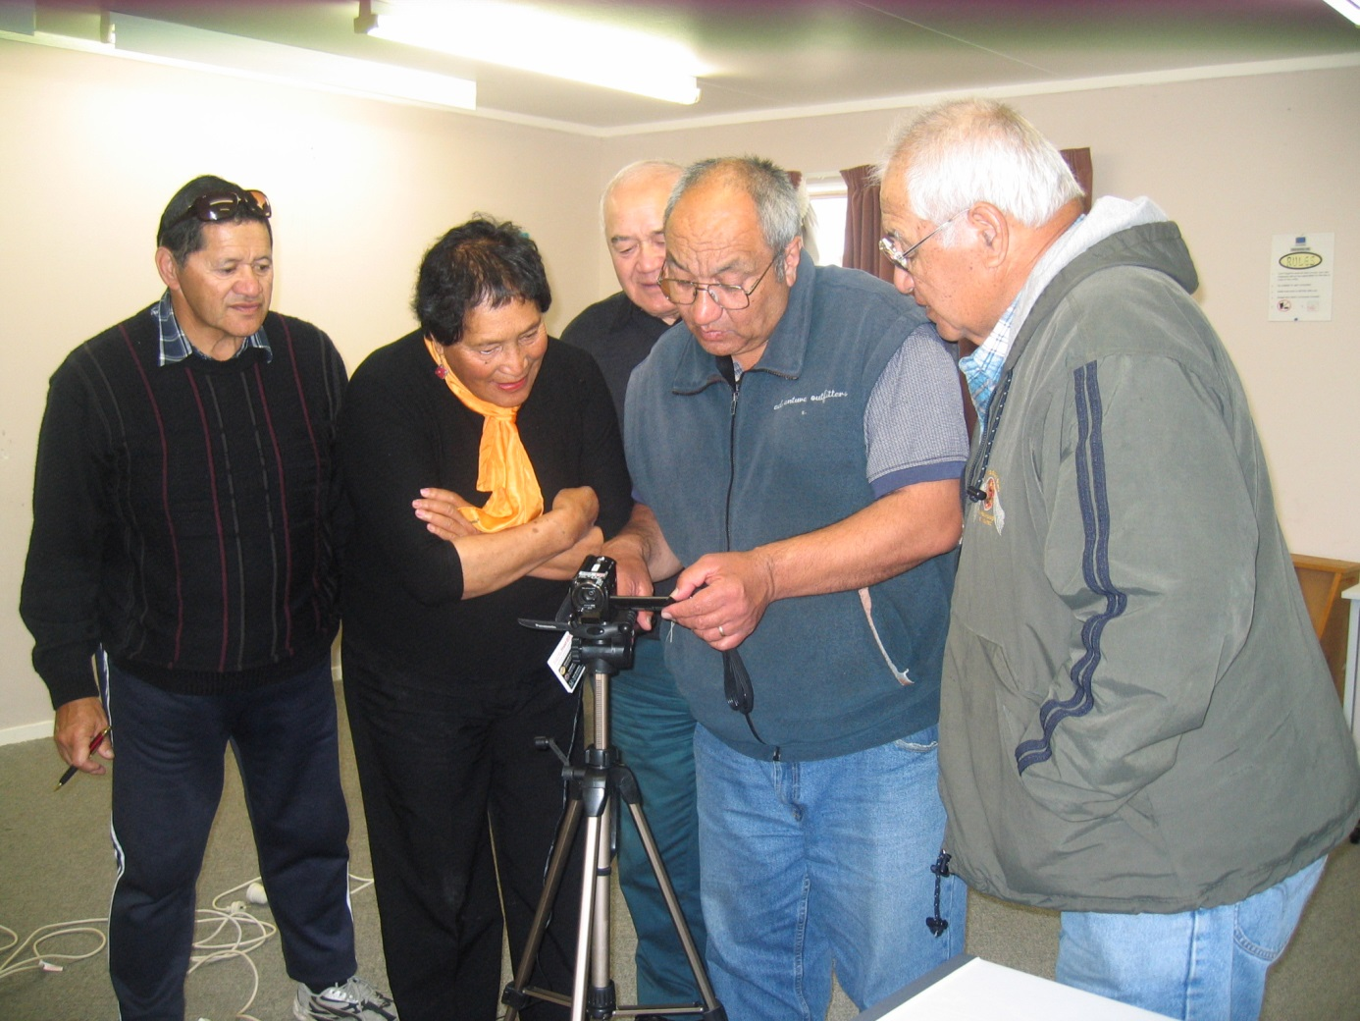

**Kia Hiwa Ra – Kia Hiwa Ra!**

**Welcome to the**

**Maori Oral Historians and Wananga PhD Graduates**

**Inaugural Conference 24-25 October 2017**

**Venue** **Te Whare Wananga o Awanuiarangi; 13 Domain Road, Whakatane 3120**

The theme of the conference is ‘*Journeys’,*  side stories within interviews

Did you participate in the **Oral History Training** offered by the Alexander Turnbull Library?

Were you involved in the **Treaty of Waitangi Claims** process for your hapu or iwi?

Were you involved with **research for your marae** or **other project**?

Were you involved with the **Iwi Community Based Language Initiative** research?

What **research methodology was utilised, what iwi specific tikanga were practised?**

Come, share the *Journeys* encountered during your research projects

The full program will be out shortly.

A brief of no more than 250 words on any of the above research topics is required for presentations.

**Contact:** Taina Tangaere McGregor **Ph: 022 041 8682** **Email:** [**taina.mcgregor@dia.govt.nz**](mailto:taina.mcgregor@dia.govt.nz?subject=Maori%20Oral%20Historians)